Oops

Name:Satya Naga Renu

Regd N0:22BEC1456;

Date:27-07-2023;

Q1) write a c program for a leap year

Code:

#include <stdio.h>

int main(){

printf("Satya Naga Renu\n");

printf("22BEC1456\n");

int a;

printf("enter the year to check whether leap year or not");

scanf("%d",&a);

if(a%400==0){

printf("leap year");

}

else if(a%100==0){

printf("not a leap year");

}

else if(a%4==0){

printf("leap year");

}

else {

printf("Not leap year");

}

}

Output;



Q2)Write a C program to input electricity unit charges and calculate total electricity bill according to the given condition: For first 50 units Rs. 0.75/unit For next 100 units Rs. 1.00/unit For next 100 units Rs. 1.25/unit For next 100 units Rs. 1.50/unit For unit above 350 Rs. 1.75/unit An additional surcharge of 20% is added to the bill

Code:

#include <stdio.h>

int main() {

int units;

float bill;

printf("Satya Naga Renu\n");

printf("22BEC1456\n");

printf("Enter the electricity units: ");

scanf("%d", &units);

if (units <= 50) {

bill = units \* 0.75;

} else if (units <= 150) {

bill = 50 \* 0.75 + (units - 50) \* 1.00;

} else if (units <= 250) {

bill = 50 \* 0.75 + 100 \* 1.00 + (units - 150) \* 1.25;

} else if (units <= 350) {

bill = 50 \* 0.75 + 100 \* 1.00 + 100 \* 1.25 + (units - 250) \* 1.50;

} else {

bill = 50 \* 0.75 + 100 \* 1.00 + 100 \* 1.25 + 100 \* 1.50 + (units - 350) \* 1.75;

}

float surcharge = 0.20 \* bill;

bill += surcharge;

printf("Total Electricity Bill: Rs. %.2f\n", bill);

    return 0;

}

0utput: 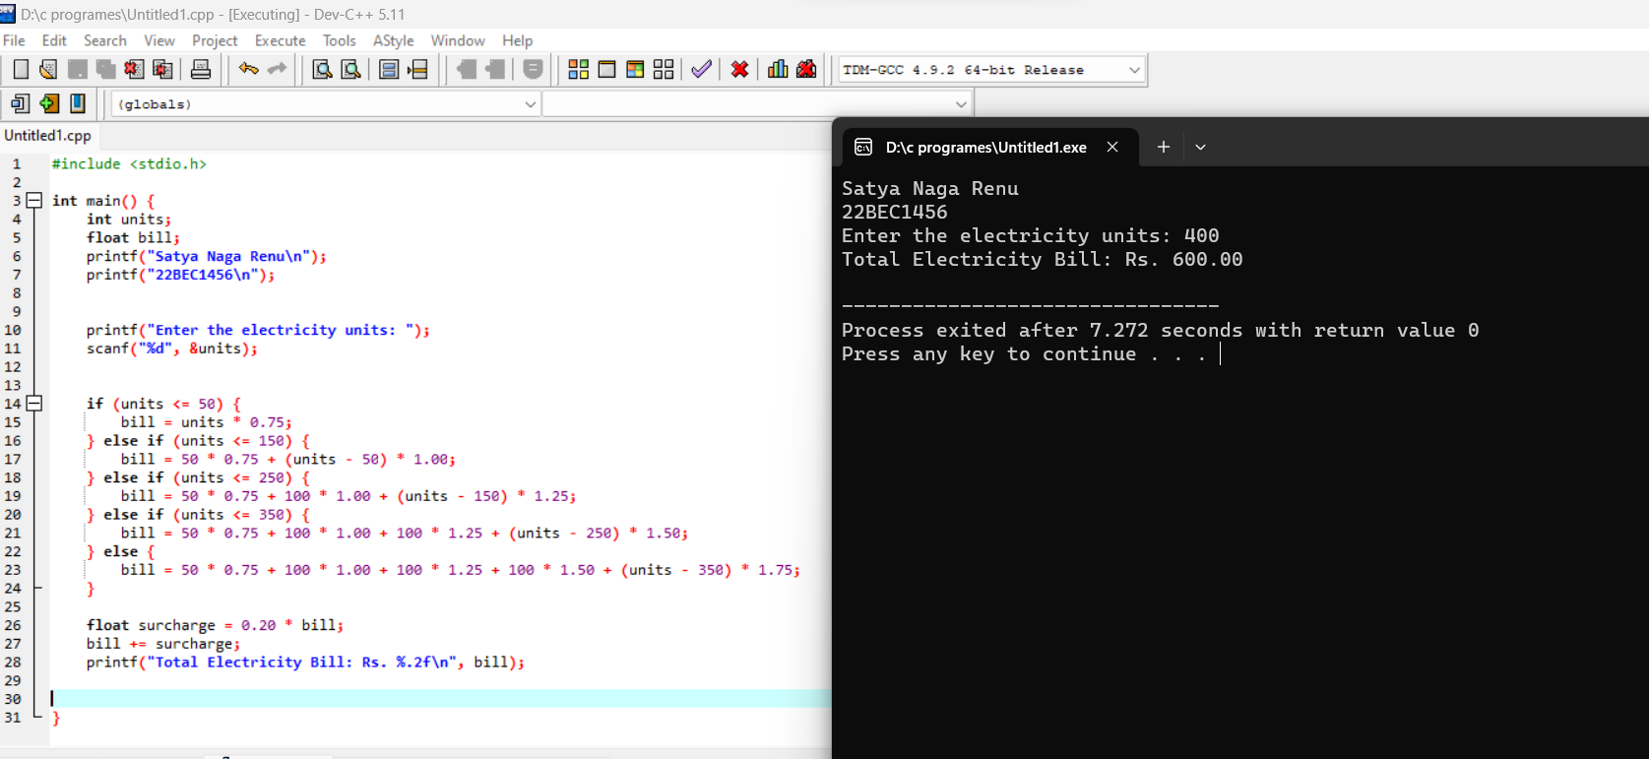

Q3) 3. Write a C program to calculate the grade secured by a student. Get the percentage of marks as input.

Marks Grade >=90 S

80 to 89 A

70 to 79 B

60 to 69 C

50 to 59

D < 50 N

CODE:

#include <stdio.h>

int main() {

printf("Satya Naga Renu\n");

printf("22BEC1456\n");

float percentage;

printf("Enter the percentage of marks: ");

scanf("%f", &percentage);

char grade;

if (percentage >= 93) {

grade = 'S';

} else if (percentage >= 80) {

grade = 'A';

} else if (percentage >= 70) {

grade = 'B';

} else if (percentage >= 60) {

grade = 'C';

} else if (percentage >= 50) {

grade = 'D';

} else {

grade = 'N';

}

printf("Grade secured: %c\n", grade);

}

OutPut:

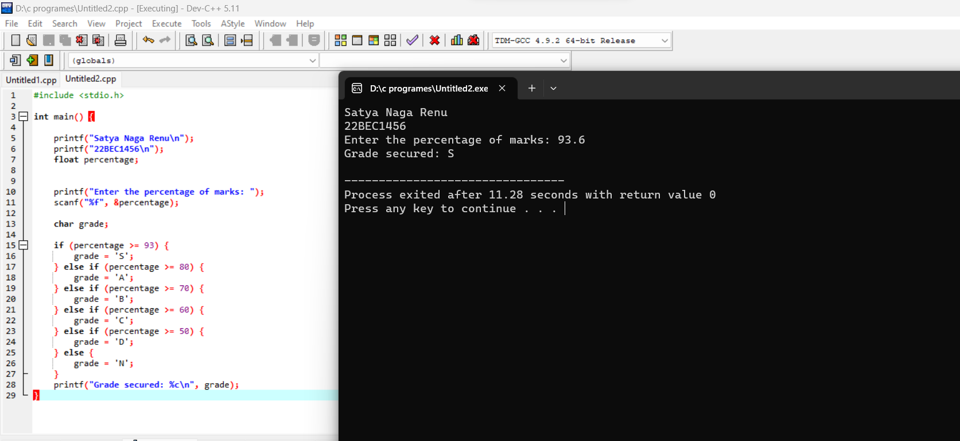

Switch case

Q4) Write a C program to mimic a calculator with basic arithmetic operations.

Code:

#include <stdio.h>

int main() {

printf("Satya Naga Renu\n");

printf("22BEC1456\n");

int num1, num2;

char operator;

printf("Enter first number: ");

scanf("%d", &num1);

printf("Enter an operator (+, -, \*, /): ");

scanf(" %c", &operator);

printf("Enter second number: ");

scanf("%d", &num2);

switch(operator) {

case '+':

printf("%d + %d = %d", num1, num2, num1 + num2);

break;

case '-':

printf("%d - %d = %d", num1, num2, num1 - num2);

break;

case '\*':

printf("%d \* %d = %d", num1, num2, num1 \* num2);

break;

case '/':

if(num2 != 0)

printf("%d / %d = %f", num1, num2, (float)num1 / num2);

else

printf("Error: Division by zero");

break;

default:

printf("Invalid operator");

}

}

Output:

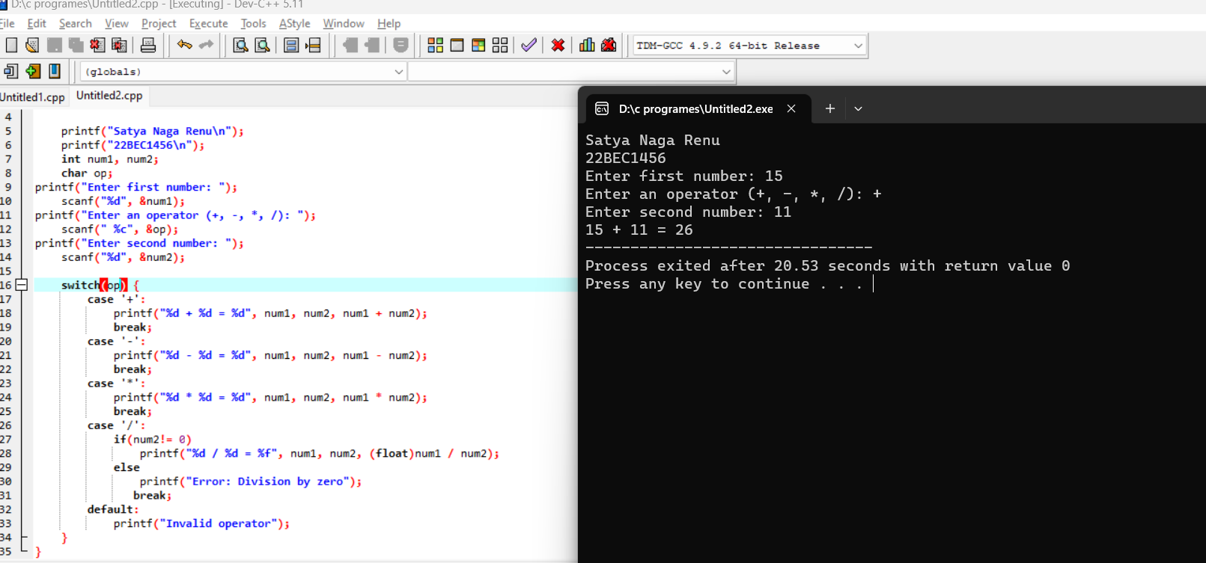

Q5)Write a C program to find the grade of the student from the marks of all five subjects using switch case.

Code:

#include <stdio.h>

int main() {

printf("Satya Naga Renu\n");

printf("22BEC1456\n");

int marks;

int sum = 0;

for (int i = 0; i < 5; ++i) {

printf("Enter marks for subject %d: ", i + 1);

scanf("%d", &marks);

sum+= marks;

}

float average = (float)sum / 5;

char grade;

switch ((int)average / 10) {

case 9:

case 10:

grade = 'S';

break;

case 8:

grade = 'A';

break;

case 7:

grade = 'B';

break;

case 6:

grade = 'C';

break;

case 5:

grade = 'D';

break;

default:

grade = 'N';

break;

}

printf("Grade: %c\n", grade);

}

Output: 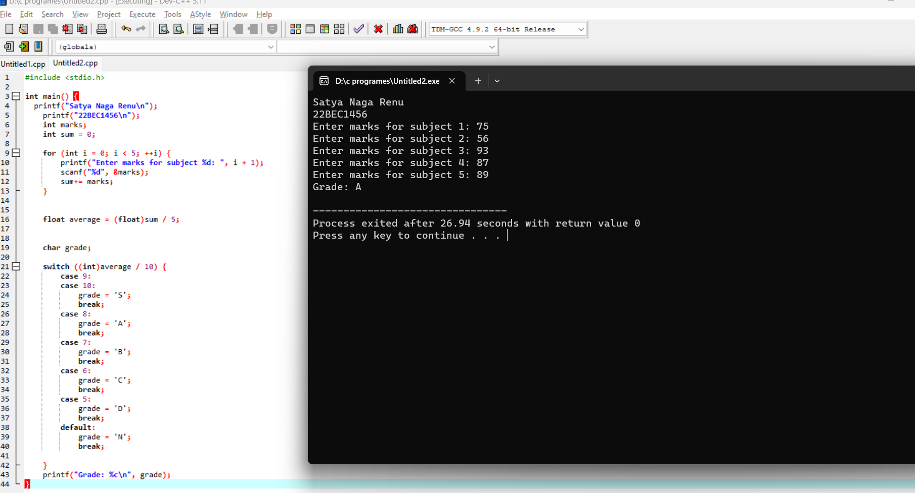

Nested Switch:

Q 6) Mr.Sinha has a jackpot ticket. The ticket number is represented as n digits integers. The winner of the jackpot is declared based on the following conditions: Winner: • If the ticket number is even and the sum of all the digits in the ticket number is even. • If the ticket number is odd and the sum of all the digits in the ticket number is odd. Write a C program that gets the jackpot ticket number as input from the user and prints either winner or looser based on the above condition using nested switch

Code: int main() {

printf("Satya Naga Renu\n");

printf("22BEC1456\n");

#include <stdio.h>

int ticketNumber;

printf("Enter the jackpot ticket number: ");

scanf("%d", &ticketNumber);

int num = ticketNumber;

int sum = 0;

while (num > 0) {

sum += num % 10;

num /= 10;

}

switch (ticketNumber % 2) {

case 0:

switch (sum % 2) {

case 0:

printf("Winner\n");

break;

case 1:

printf("Loser\n");

break;

}

break;

case 1:

switch (sum % 2) {

case 0:

printf("Loser\n");

break;

case 1:

printf("Winner\n");

break;

}

break;

}

}

Output: 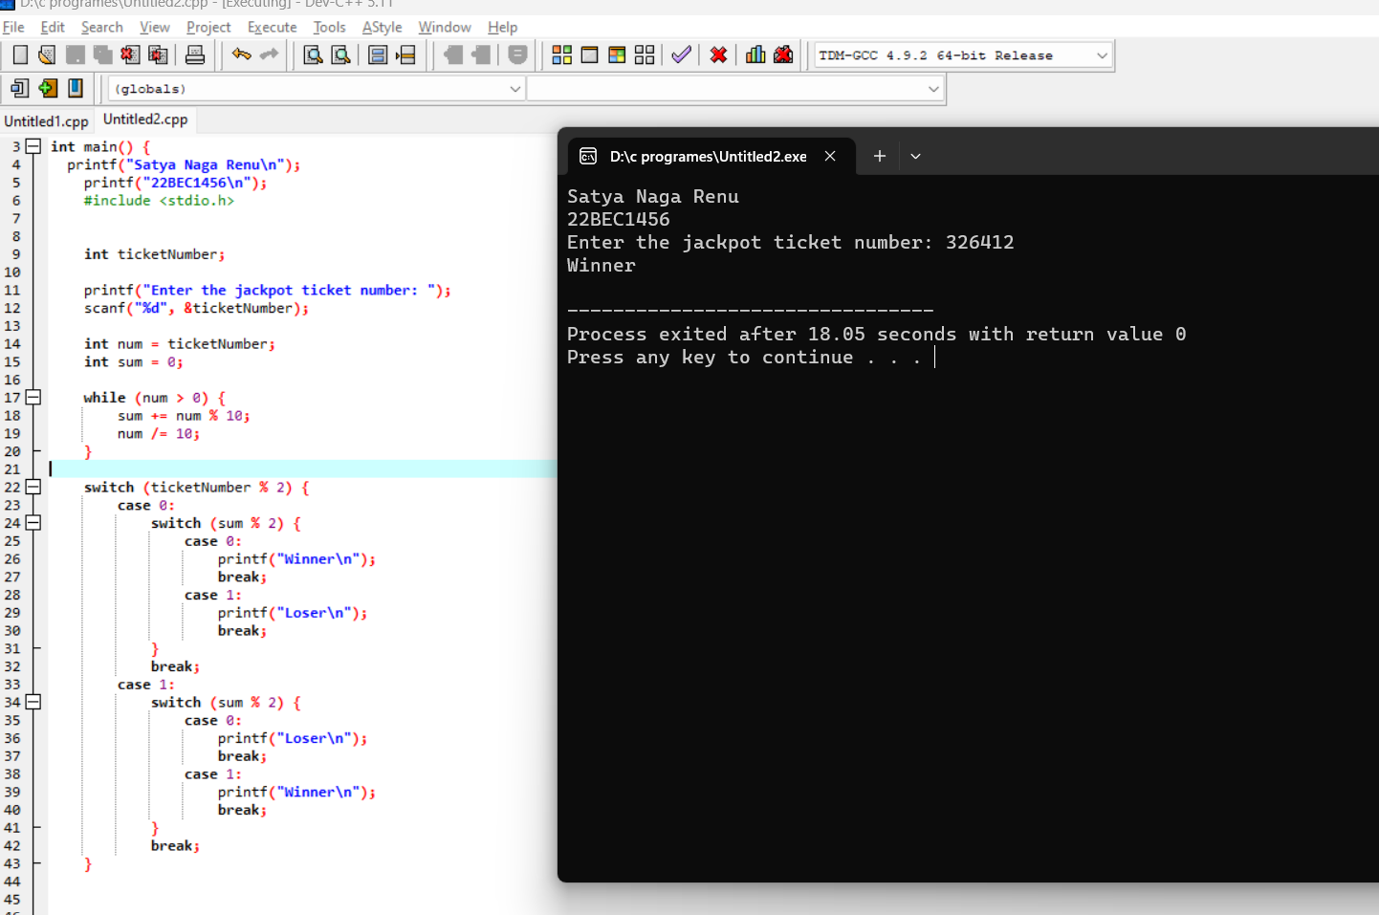

Date:31-07-2023

Q1) Write a C program using for loop to check whether a given number is palindrome or not

Code;

#include <stdio.h>

int main() {

printf("Satya Naga Renu\n");

printf("22BEC1456\n");

int originalNumber, reversedNumber = 0, remainder, num;

printf("Enter a number: ");

scanf("%d", &originalNumber);

num = originalNumber;

for (; num > 0; num /= 10) {

remainder = num % 10;

reversedNumber = reversedNumber \* 10 + remainder;

}

if (reversedNumber == originalNumber) {

printf("%d is a palindrome.\n", originalNumber);

} else {

printf("%d is not a palindrome.\n", originalNumber);

}

return 0;

}

Output:

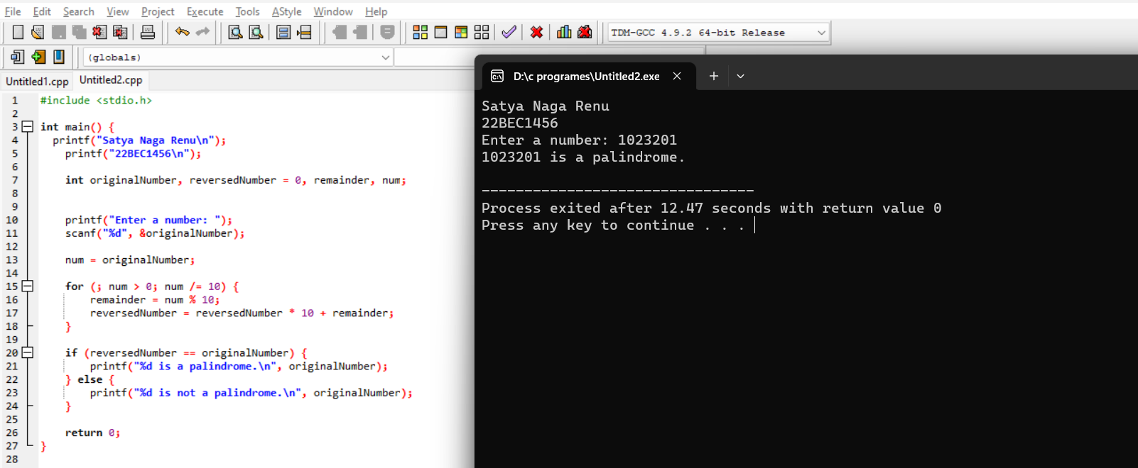

Q2) Write a C program to find the sum of the following series. Get the maximum power

term from user as input

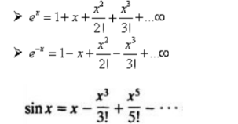

CODE:

#include<stdio.h>

void main(){

printf("Satya Naga Renu\n");

printf("22BEC1456\n");

int x;

float s1;

float s2;

float s3;

int max;

int powx = 1;

int npowx = 1;

int oddnpowx = x;

int fac = 1;

int oddfac = 1;

printf("Enter value of x:");

scanf("%d",&x);

printf("Enter max power:");

scanf("%d",&max);

int n;

s1 = 1;

s2 = 1;

s3 = 0;

for(n = 1;n<=max;n++){

fac \*= n;

oddfac \*= (2\*(n-1)+1);

powx \*= x;

npowx \*= -x;

s1 += (float)powx/fac;

s2 += (float)npowx/fac;

s3 += (float)oddnpowx/oddfac;

oddnpowx \*= -(x\*x);

}

printf("Series 1 (e^x) is %f\n",s1);

printf("Series 2 (e^(-x)) is %f\n",s2);

printf("Series 3 (sinx) is %f\n",s3);

}

OUTPUT:

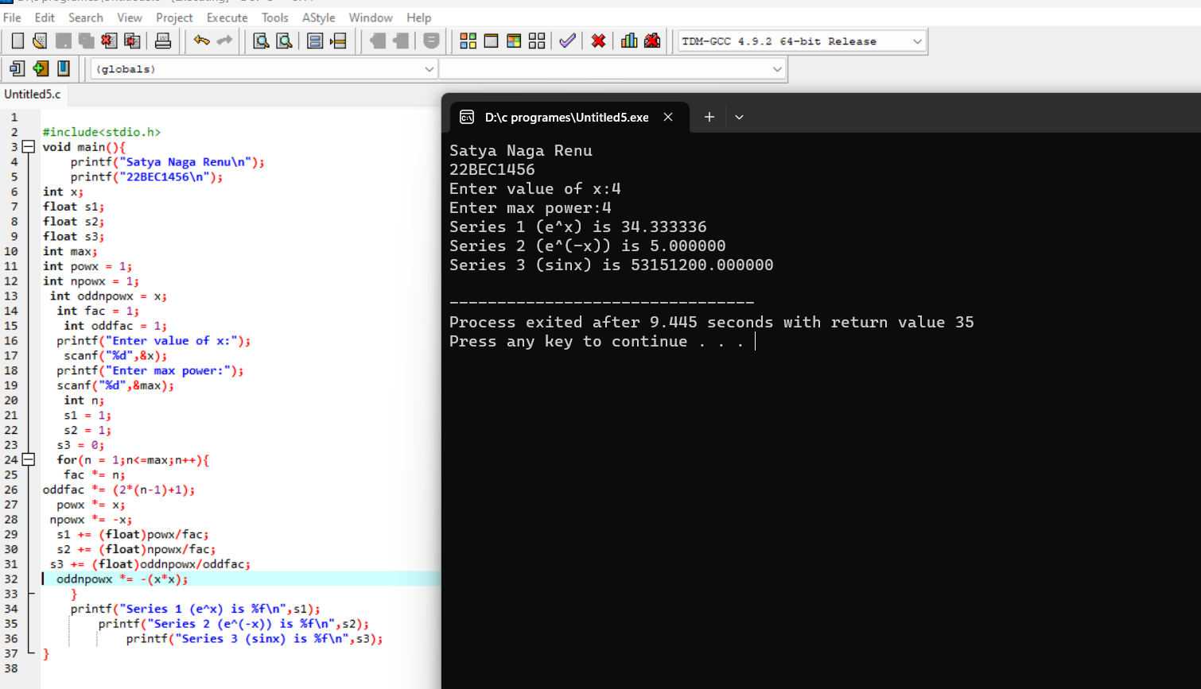

Q3) Write a C program to list all the 'Perfect' numbers within a given number of ranges. Get the lower and upper limits as input. Note: A perfect number is a positive integer that is equal to the sum of its proper divisors

Code: #include <stdio.h>

int isPerfect(int num) {

int sum = 0;

for (int i = 1; i <= num / 2; ++i) {

if (num % i == 0) {

sum += i;

}

}

return sum == num;

}

int main() {

printf("Satya Naga Renu\n");

printf("22BEC1456\n");

int lowerLimit, upperLimit;

printf("Enter lower limit: ");

scanf("%d", &lowerLimit);

printf("Enter upper limit: ");

scanf("%d", &upperLimit);

printf("Perfect numbers between %d and %d:\n", lowerLimit, upperLimit);

for (int num = lowerLimit; num <= upperLimit; ++num) {

if (isPerfect(num)) {

printf("%d\n", num);

}

}

return 0;

}

Output:

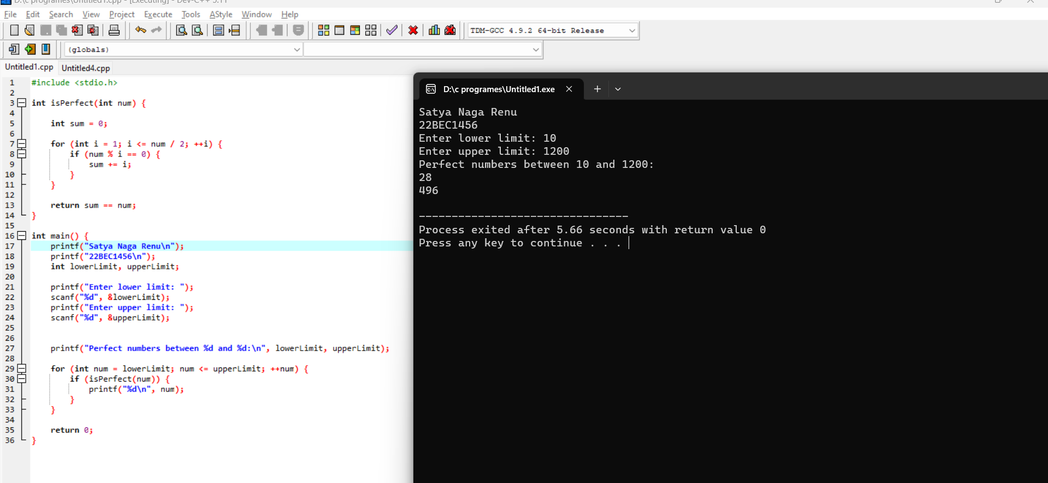

While Loop

Q4) Using while loop, write a C program to display the sum of the series [ 9 + 99 + 999 + 9999 ...]. Get the number of terms as input from user.

Code:

int main() {

printf("Satya Naga Renu\n ");

printf("22BEC1456\n");

int numTerms;

long long int term = 9;

long long int sum = 0;

printf("Enter the number of terms: ");

scanf("%d", &numTerms);

int count = 0;

while (count < numTerms) {

sum += term;

term = term \* 10 + 9;

count++;

}

printf("Sum of the series: %lld\n", sum);

}

Output:

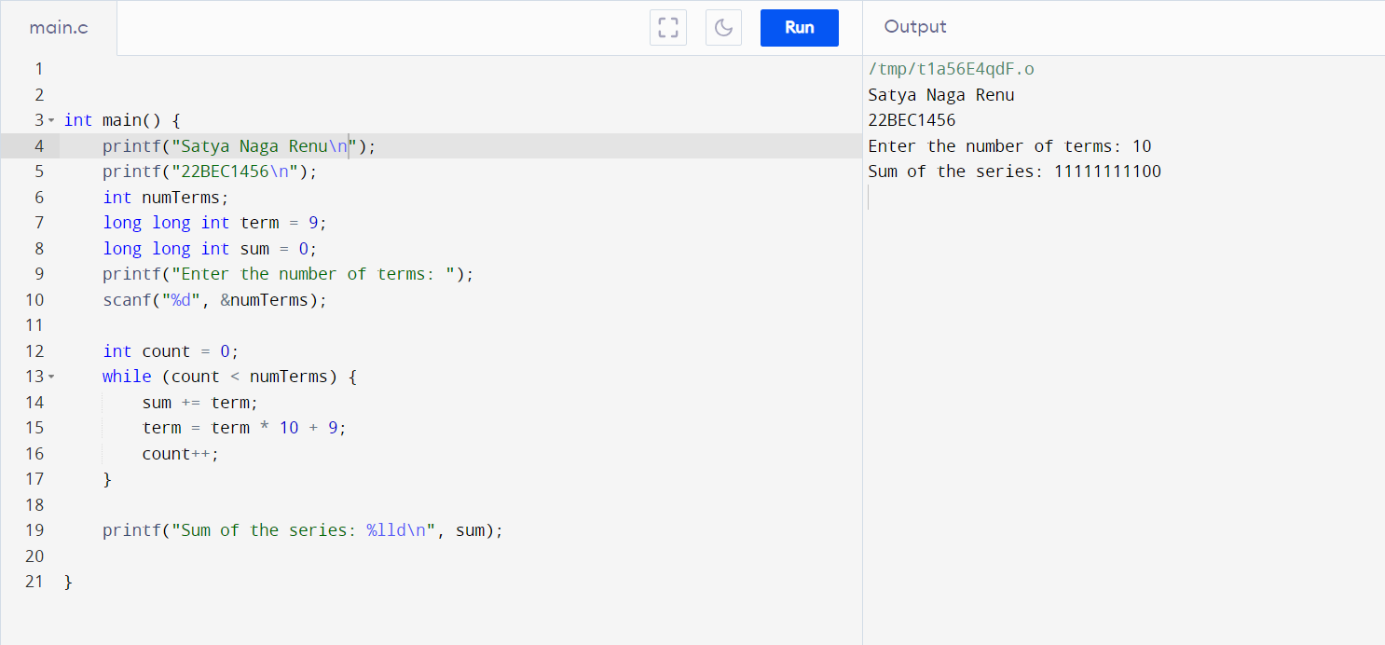

Q5) Get an integer with value greater than 10000. If the input is less than or equal to 10000, prompt the user to enter a valid input. Write a C program using while loop that computes • No. of digits in the number, number of odd numbered digits in the number and number of even numbered digits in the number. • Sum of Digits, sum of even numbered digits and sum of odd numbered digits of a Number

Code: #include<stdio.h>

int main() {

printf("Satya Naga Renu\n");

printf("22BEC1456\n");

int number, originalNumber, digitCount = 0, oddCount = 0, evenCount = 0;

int digitSum = 0, oddSum = 0, evenSum = 0;

do {

printf("Enter an integer greater than 10000: ");

scanf("%d", &number);

if(number<10000){

printf("invalid input\n");

}

} while (number <= 10000);

originalNumber = number;

while (number > 0) {

int digit = number % 10;

digitCount++;

digitSum += digit;

if (digit % 2 == 0) {

evenCount++;

evenSum += digit;

} else {

oddCount++;

oddSum += digit;

}

number /= 10;

}

printf("Number of digits: %d\n", digitCount);

printf("Number of odd digits: %d\n", oddCount);

printf("Number of even digits: %d\n", evenCount);

printf("Sum of digits: %d\n", digitSum);

printf("Sum of odd digits: %d\n", oddSum);

printf("Sum of even digits: %d\n", evenSum);

}

Output: 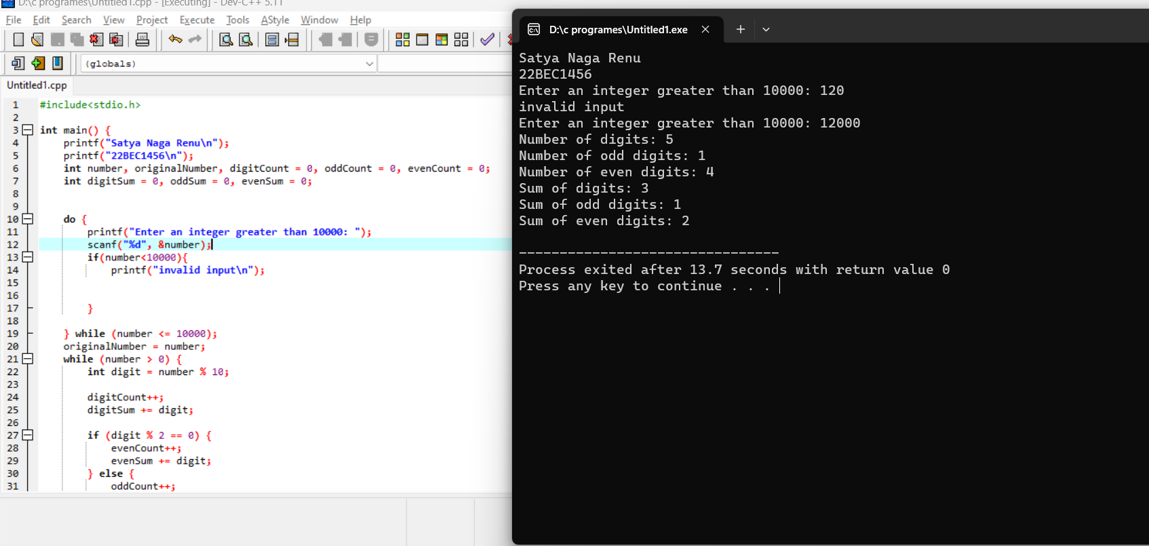Do while loop:

Q6)Write a C program to find the sum of

• ‘n’ natural numbers

• ‘n’ even natural numbers

Code:

#include<stdio.h>

int main() {

printf("Satya Naga Renu\n");

printf("22BEC1456\n");

int n;

printf("Enter the value of n: ");

scanf("%d", &n);

int sumNaturals = 0;

int sumEvenNaturals = 0;

int i = 1;

do {

sumNaturals += i;

if (i % 2 == 0) {

sumEvenNaturals += i;

}

i++;

} while (i <= n);

printf("Sum of %d natural numbers: %d\n", n, sumNaturals);

printf("Sum of %d even natural numbers: %d\n", n, sumEvenNaturals);

return 0;

}

Output:

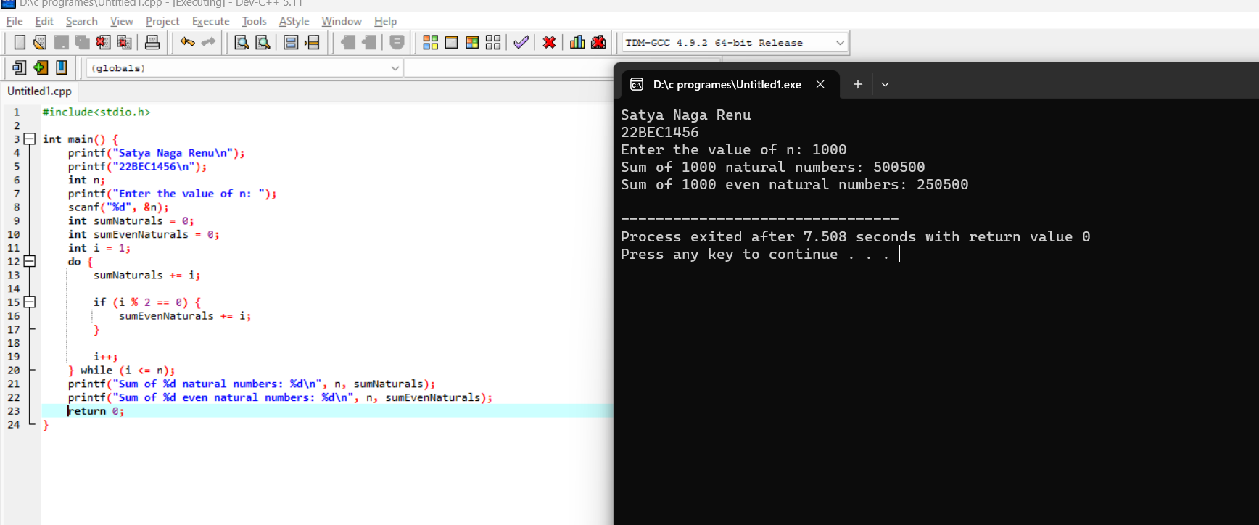

Date:03-08-2023;

Q1) Write a C program to find the largest of three numbers using conditional operator

CODE:

#include<stdio.h>

void main(){

printf("Satya Naga Renu\n");

printf("22BEC1456\n");

int a,b,c;

printf("Enter three numbers:");

scanf("%d %d %d", &a,&b,&c);

int max;

max=a>b&&a>c?a:b>c?b:c;

printf("the largest number is %d",max);

}

OUTPUT: 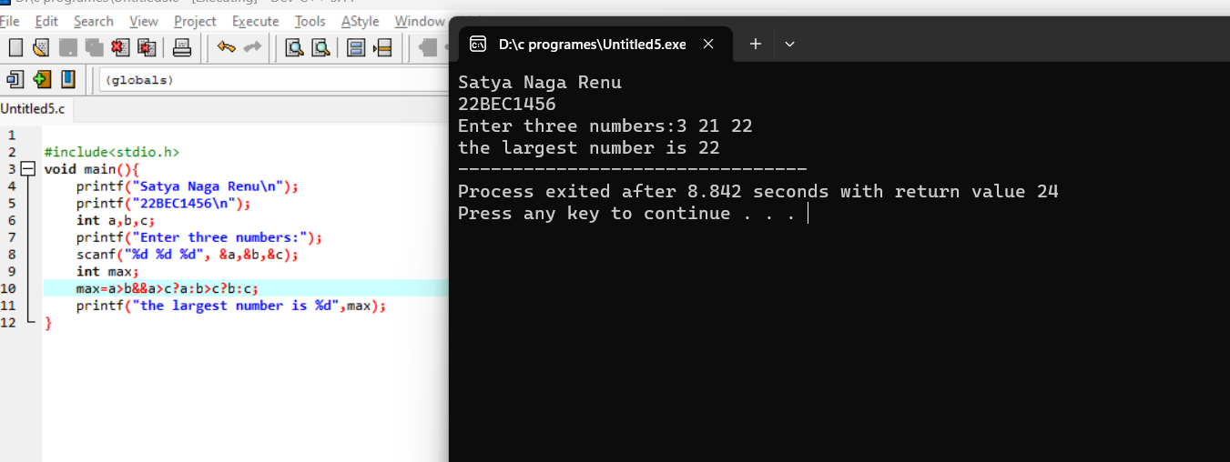

Q2) Write a C program to find the largest and smallest element in an array. Initialize the array with user input.

CODE:

#include<stdio.h>

void main(){

printf("Satya Naga Renu\n");

printf("22BEC1456\n");

int size;

int i;

printf("Enter the size of the array: ");

scanf("%d", &size);

int ar[size];

printf("Enter %d elements:\n", size);

for (i = 0; i < size; ++i) {

scanf("%d", &ar[i]);

}

int largest = ar[0];

int smallest = ar[0];

for (i = 1; i < size; ++i) {

if (ar[i] > largest) {

largest = ar[i];

}

if (ar[i] < smallest) {

smallest = ar[i];

}

}

printf("Largest element: %d\n", largest);

printf("Smallest element: %d\n", smallest);

return 0;

}

OUTPUT: 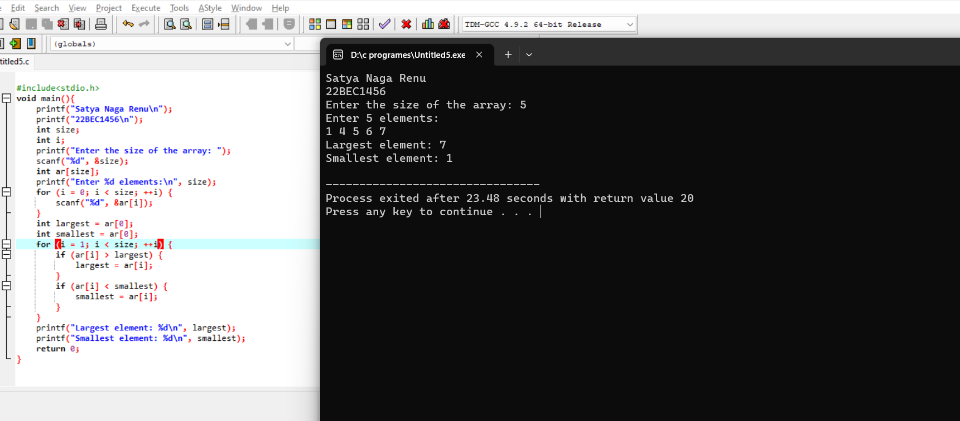

Q3) Write a C program to sort an array in ascending and descending order. Initialize the array with user input.

CODE:

#include<stdio.h>

void main(){

printf("Satya Naga Renu\n");

printf("22BEC1456\n");

int x,y,n,temp;

printf("enter the total no:of numbers");

scanf("%d",&n);

int arr[n],asc[n],des[n];

printf("enter the numbers");

for(x=0;x<n;x++){

scanf("%d",&arr[x]);

}

for (x=0;x<n;x++){

for(y=x;y<n;y++){

if(arr[x]>arr[y]){

temp=arr[y];

arr[y]=arr[x];

arr[x]=temp;

}

}

}

printf("Ascending\n");

for(x=0;x<n;x++){

printf("%d\n",arr[x]);

}

printf("Descending\n");

for(y=x-1;y>=0;y--){

printf("%d\n",arr[y]);

}

}  
OUTPUT:  
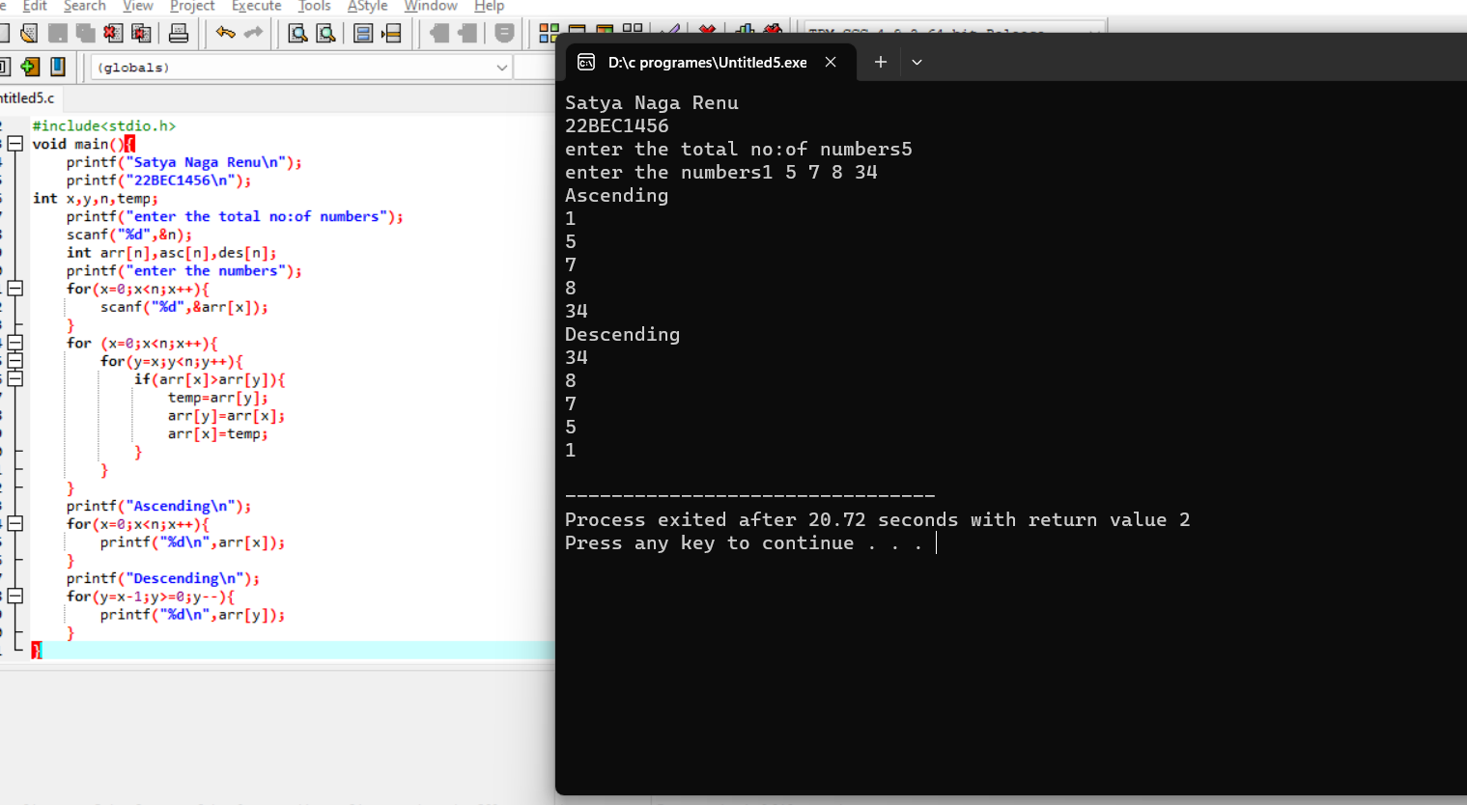

Q4) . Write a C program to separate the even and odd numbers in an array to two separate arrays. Initialize the array with user input.

CODE:

#include<stdio.h>

void main(){

printf("Satya Naga Renu\n");

printf("22BEC1456\n");

int size;

printf("Enter the size of the array: ");

scanf("%d", &size);

int originalArray[size];

int evenArray[size];

int oddArray[size];

int i;

printf("Enter %d elements:\n", size);

for (i = 0; i < size; ++i) {

scanf("%d", &originalArray[i]);

}

int evenCount = 0, oddCount = 0;

for (i = 0; i < size; ++i) {

if (originalArray[i] % 2 == 0) {

evenArray[evenCount++] = originalArray[i];

} else {

oddArray[oddCount++] = originalArray[i];

}

}

printf("Even numbers array:\n");

for (i = 0; i < evenCount; ++i) {

printf("%d ", evenArray[i]);

}

printf("\n");

printf("Odd numbers array:\n");

for (i = 0; i < oddCount; ++i) {

printf("%d ", oddArray[i]);

}

printf("\n");

}

OUTPUT: 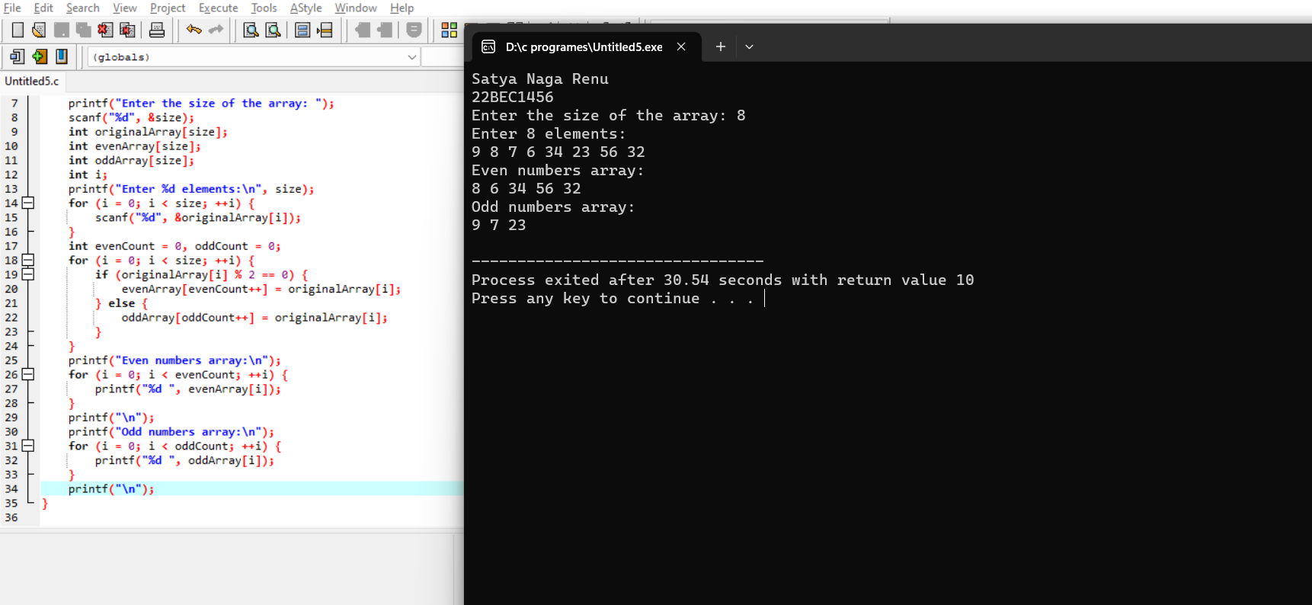

Q5) Write a C program to insert an element into an array. Initialize the array with user input. Get the position and the element to be inserted as input from the user

CODE:

#include<stdio.h>

void main(){

printf("Satya Naga Renu\n");

printf("22BEC1456\n");

int arr[100], n, pos, x,i;

printf("Enter the size of the array: ");

scanf("%d", &n);

printf("Enter the elements of the array: ");

for(i=0; i<n; i++) {

scanf("%d", &arr[i]);

}

printf("Enter the position where you want to insert the element: ");

scanf("%d", &pos);

printf("Enter the element to be inserted: ");

scanf("%d", &x);

for(i=n-1; i>=pos-1; i--) {

arr[i+1] = arr[i];

}

arr[pos-1] = x;

printf("The new array is: ");

for(i=0; i<=n; i++) {

printf("%d ", arr[i]);

}

return 0;

}  
OUTPUT: 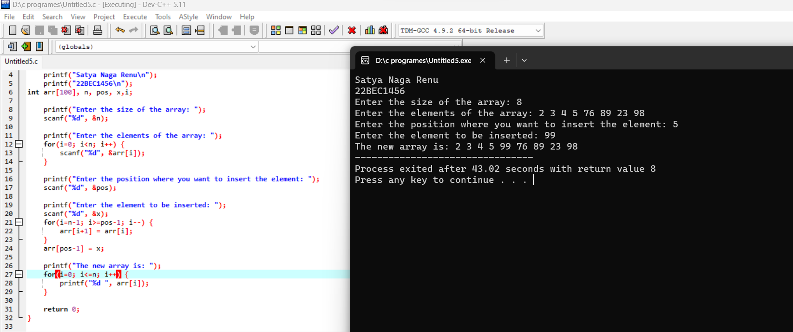

Date:07-08-2023;

Q1) Write a C program to perform the addition of two matrices.

CODE:

#include <stdio.h>

int main() {

printf("Satya Naga Renu\n");

printf("22BEC1456\n");

int m[10][10],i,j,row1,col1,row2,col2,n[10][10],k[10][10],sum;

printf("enter number of rows and columun\n");

scanf("%d%d",&row1,&col1);

printf("enter the first matrix\n");

for(i=0;i<row1;i++){

for(j=0;j<col1;j++){

scanf("%d",&m[i][j]);

}

}

printf("enter number of rows and columun\n");

scanf("%d%d",&row2,&col2);

printf("enter the second matrix\n");

for(i=0;i<row2;i++){

for(j=0;j<col2;j++){

scanf("%d",&n[i][j]);

}

}

if(col1==col2&&row1==row2){

for(i=0;i<row1;i++){

for(j=0;j<col2;j++){

sum=m[i][j]+n[i][j];

k[i][j]=sum;

sum=0;

}

}

}

else{

printf("invalid matrix");

}

printf("output matrix\n");

for(i=0;i<row1;i++){

for(j=0;j<col2;j++){

printf("%d\t",k[i][j]);

}

printf("\n");

}

return 0;

}

OUTPUT: 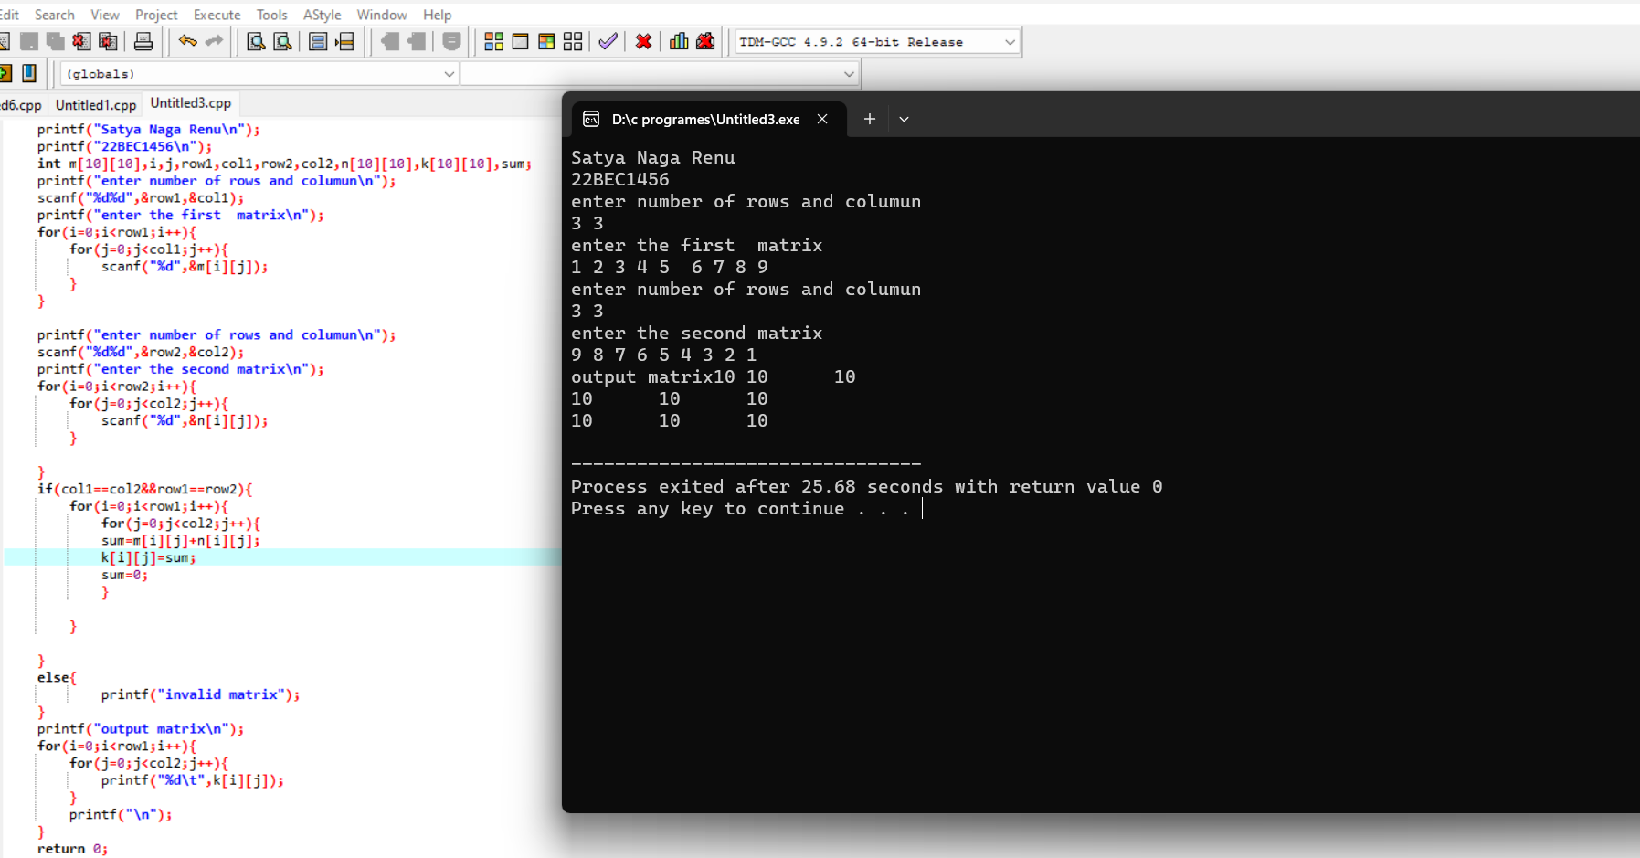

Q2) Write a C program to multiply two matrices.

CODE:

#include <stdio.h>

int main() {

printf("Satya Naga Renu\n");

printf("22BEC1456\n");

int m[10][10],i,j,a,row1,col1,row2,col2,n[10][10],k[10][10],sum,b;

printf("enter number of rows and columun\n");

scanf("%d%d",&row1,&col1);

printf("enter the first matrix\n");

for(i=0;i<row1;i++){

for(j=0;j<col1;j++){

scanf("%d",&m[i][j]);

}

}

printf("enter number of rows and columun\n");

scanf("%d%d",&row2,&col2);

printf("enter the second matrix\n");

for(i=0;i<row2;i++){

for(j=0;j<col2;j++){

scanf("%d",&n[i][j]);

}

}

if(col1==row2){

for(i=0;i<row1;i++){

for(j=0;j<col2;j++){

for(a=0;a<col1;a++){

sum=sum+m[i][a]\*n[a][j];

k[i][j]=sum;

}

sum=0;

}

}

printf("output matrix\n");

for(i=0;i<row1;i++){

for(j=0;j<col2;j++){

printf("%d\t",k[i][j]);

}

printf("\n");

}

}

else{

printf("invalid matrix");

}

return 0;

}  
  
OUTPUT:

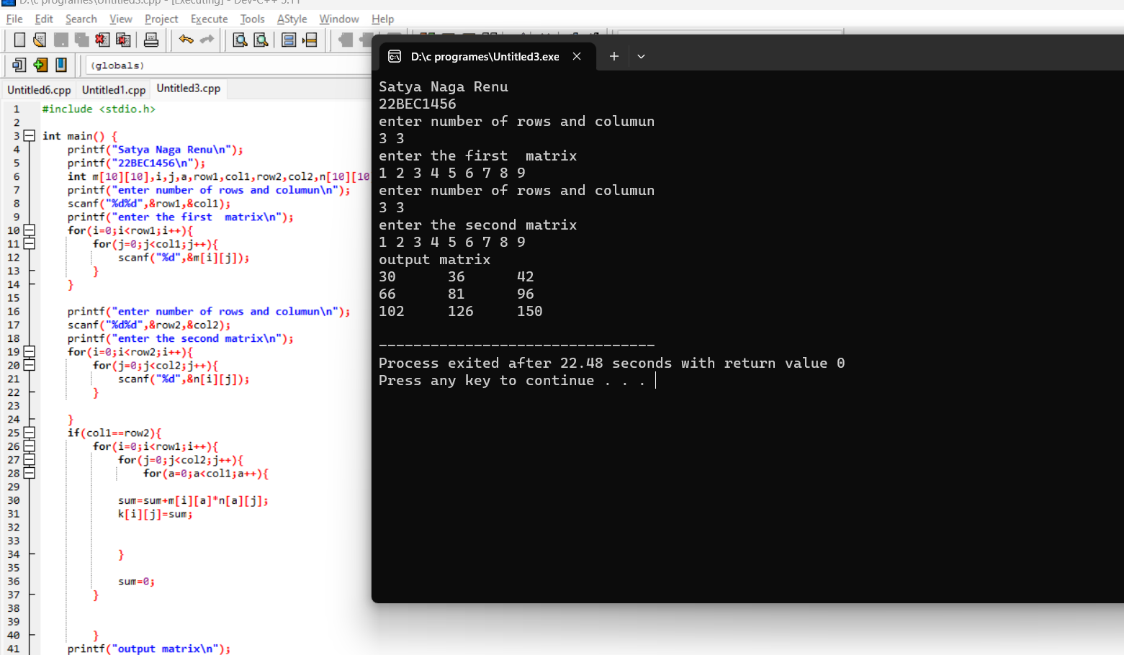

Q3) Write a C program to find the sum of major and minor diagonal elements of a matrix.

CODE: #include <stdio.h>

int main() {

printf("Satya Naga Renu\n");

printf("22BEC1456\n");

int size;

printf("Enter the size of the square matrix: ");

scanf("%d", &size);

int matrix[size][size];

printf("Enter the elements of the matrix:\n");

for (int i = 0; i < size; i++) {

for (int j = 0; j < size; j++) {

scanf("%d", &matrix[i][j]);

}

}

int majorSum = 0;

int minorSum = 0;

for (int i = 0; i < size; i++) {

majorSum += matrix[i][i];

minorSum += matrix[i][size - i - 1];

}

printf("Major Diagonal Sum: %d\n", majorSum);

printf("Minor Diagonal Sum: %d\n", minorSum);

}

OUTPUT:

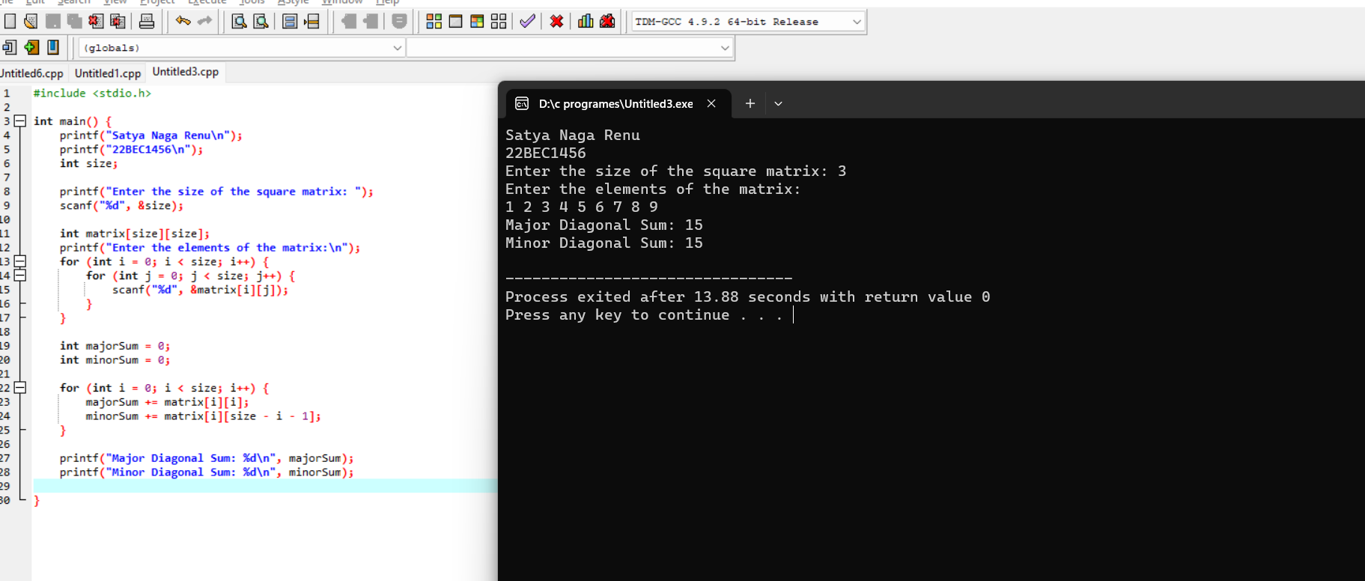

Q4) Write a C program to print the lower and upper triangle elements of a matrix

CODE:

#include <stdio.h>

int main() {

printf("Satya Naga Renu\n");

printf("22BEC1456\n");

int m[10][10],i,j,row1,col1;

printf("enter number of rows and columun\n");

scanf("%d%d",&row1,&col1);

printf("enter the first matrix\n");

for(i=0;i<row1;i++){

for(j=0;j<col1;j++){

scanf("%d",&m[i][j]);

}

}

printf("upper triangle matrix\n");

for(i=0;i<row1;i++){

for(j=0;j<row1;j++){

if(i<=j){

printf("%d\n",m[i][j]);

}

}

}

printf("low triangle matrix\n");

for(i=0;i<row1;i++){

for(j=0;j<row1;j++){

if(i>=j){

printf("%d\n",m[i][j]);

}

}

}

return 0;

}  
OUTPUT:

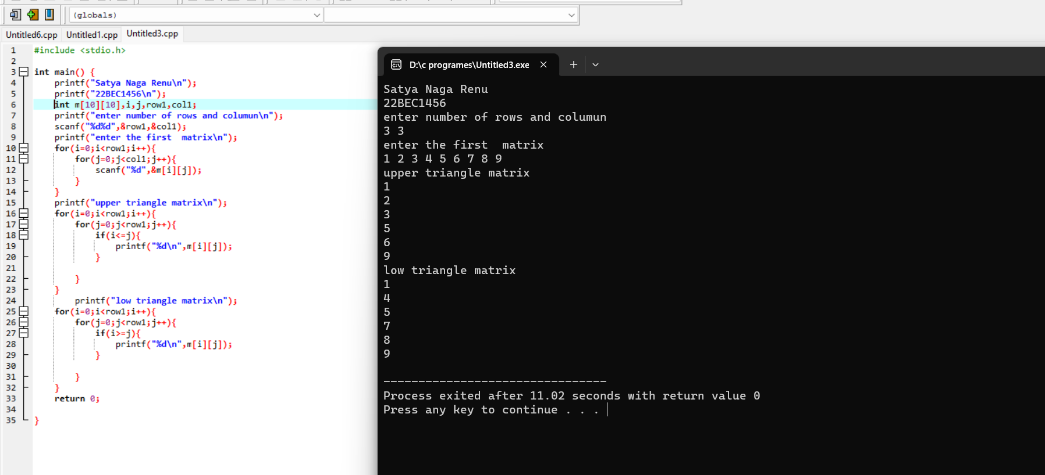

Q5)Write a C program to compute the sum of each row of a matrix and store the sum in

an array.

CODE: #include <stdio.h>

int main() {

printf("Satya Naga Renu\n");

printf("22BEC1456\n");

int m[10][10], i, j, row1, col1, sum;

int n[10];

printf("enter number of rows and columns\n");

scanf("%d%d", &row1, &col1);

printf("enter the first matrix\n");

for (i = 0; i < row1; i++) {

for (j = 0; j < col1; j++) {

scanf("%d", &m[i][j]);

}

}

for (i = 0; i < row1; i++) {

sum = 0; // Reset sum for each row

for (j = 0; j < col1; j++) {

sum += m[i][j];

}

n[i] = sum;

}

for (i = 0; i < row1; i++) {

printf("%d\n", n[i]);

}

return 0;

}

OUTPUT:

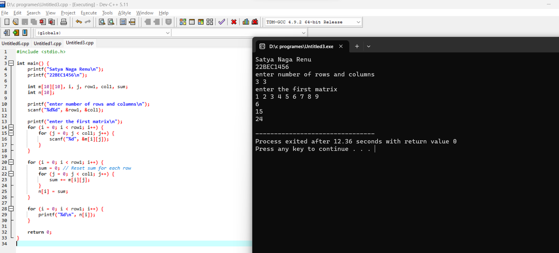

Q6) Write a C program to compute the sum of each column of a matrix and store the sum

in an array.  
CODE:

#include <stdio.h>

int main() {

printf("Satya Naga Renu\n");

printf("22BEC1456\n");

int m[10][10], i, j, row1, col1, sum;

int n[10];

printf("enter number of rows and columns\n");

scanf("%d%d", &row1, &col1);

printf("enter the first matrix\n");

for (i = 0; i < row1; i++) {

for (j = 0; j < col1; j++) {

scanf("%d", &m[i][j]);

}

}

for (i = 0; i < row1; i++) {

sum = 0; // Reset sum for each row

for (j = 0; j < col1; j++) {

sum += m[j][i];

}

n[i] = sum;

}

for (i = 0; i < row1; i++) {

printf("%d\n", n[i]);

}

return 0;

}

OUTPUT:

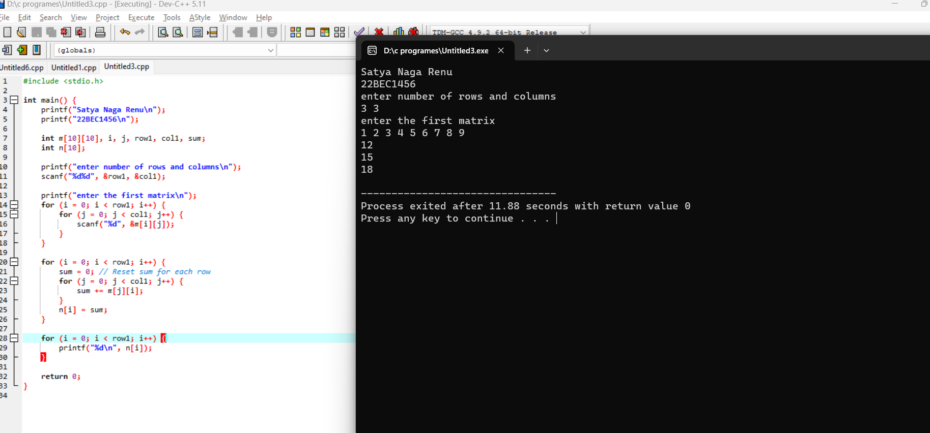

Date:10-08-2023;

Q1) Write a C program to count the number of vowels and consonants in a sentence given as

Input.

CODE:

#include <stdio.h>

int main() {

printf("Satya Naga Renu\n");

printf("22BEC1456\n");

int i;

int consonants,vowels;

char word[100];

printf("enter the string\n");

gets(word);

for(i=0;word[i]!='\0';i++){

if(word[i]=='a'||word[i]=='e'||word[i]=='i'||word[i]=='o'||word[i]=='u'||word[i]=='A'||word[i]=='E'||word[i]=='I'||word[i]=='O'||word[i]=='U'){

vowels++;

}

else{

consonants++;

}

}

printf("constants are %d\n",consonants);

printf("vowels are %d\n",vowels);

}

OUTPUT:

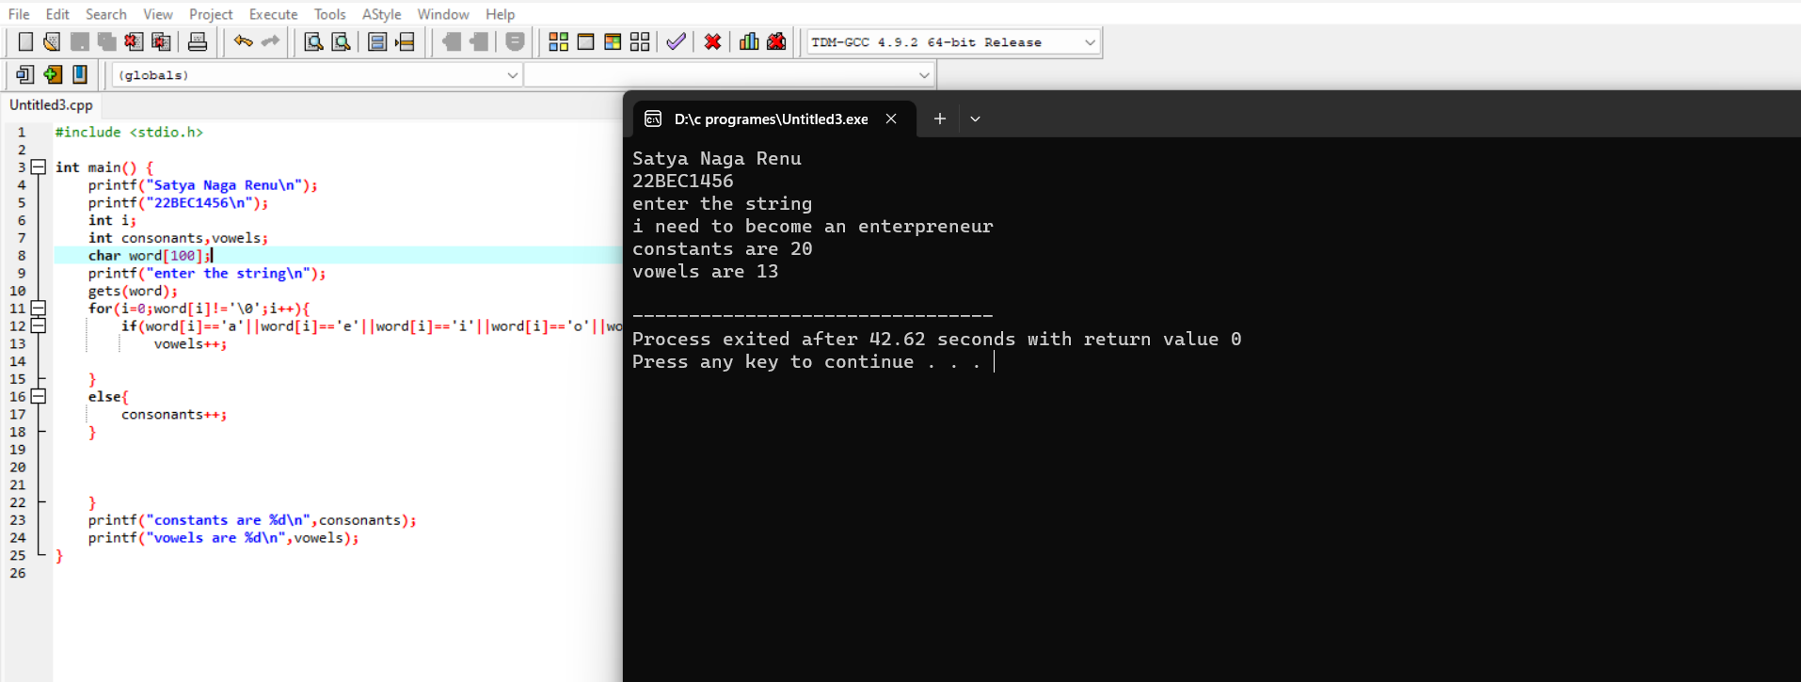

Q2)Write a c program to count the number of words in a sentence given as input.

CODE:

#include <stdio.h>

int main() {

printf("Satya Naga Renu\n");

printf("22BEC1456\n");

char text[100];

fgets(text,100,stdin);

int count;

int i=0;

while(text[i]!='\0'){

if(text[i]==' '||text[i]=='.'){

count++;

}

i++;

}

printf("The number words %d",count);

}  
  
OUTPUT:

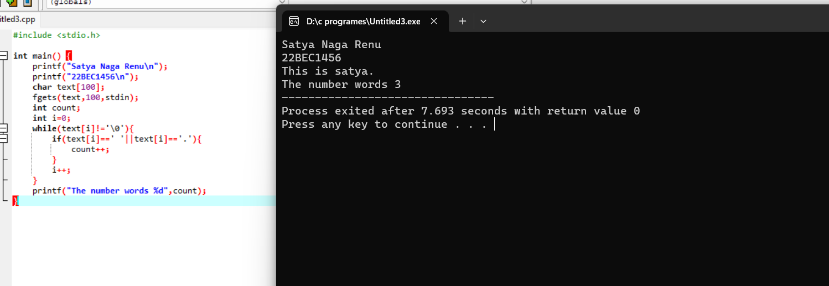

Q3) Write a C program to separate the words in a sentence given as input and store them in an

array of strings.

CODE:

#include <stdio.h>

#include<string.h>

int main() {

printf("Satya Naga Renu\n");

printf("22BEC1456\n");

char str1[100];

char newString[10][10];

int i,j,ctr;

printf("\n\n Split string by space into words :\n");

printf(" Input a string : ");

fgets(str1, sizeof str1, stdin);

j=0; ctr=0;

for(i=0;i<=(strlen(str1));i++)

{

if(str1[i]==' '||str1[i]=='\0')

{

newString[ctr][j]='\0';

ctr++;

j=0;

}

else

{

newString[ctr][j]=str1[i];

j++;

}

}

printf("\n Strings or words after split by space are :\n");

for(i=0;i < ctr;i++)

printf(" %s\n",newString[i]);

return 0;

}  
  
OUTPUT:

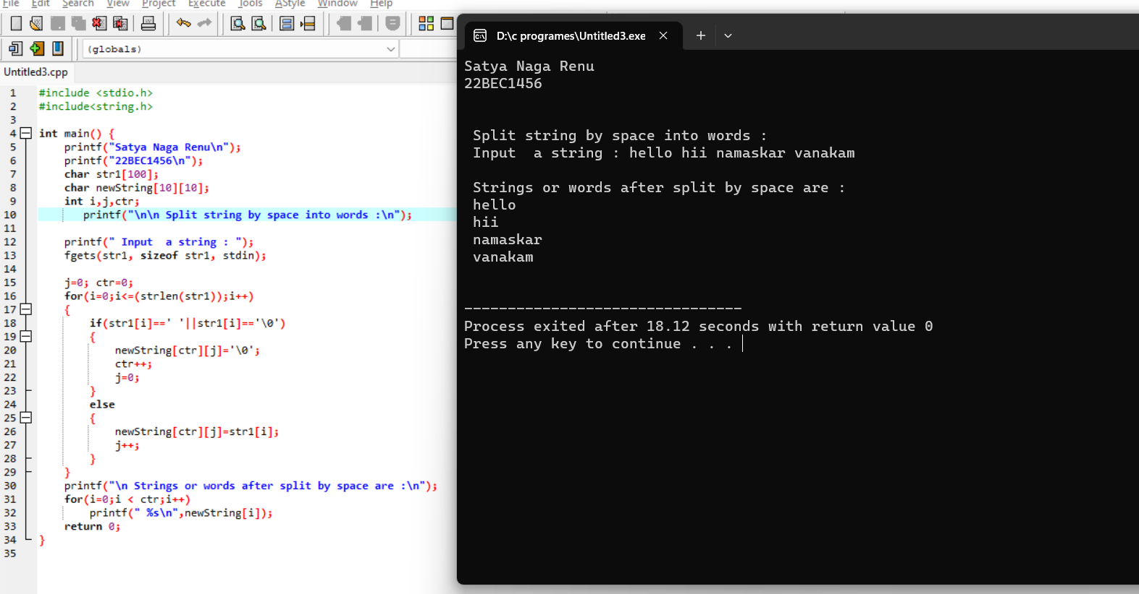

Q4) Create an application using C to encrypt the password in banking application. The password

should contain only alphabets and no numerical and special characters are allowed. The

encryption algorithm is as follows:

The vowels in the password are encoded as numbers:

a: 1, e:2, i:3, o:4 and u:5.

Consonants are replaced by alphabets lying on the 3rd position to the right. For instance, ‘b’ is

encoded as ‘e’, ‘d’ is encoded as ‘g’.

Display the encrypted version of the password.

CODE:

#include <stdio.h>

#include <string.h>

#include <ctype.h>

void encryptPassword(char \*password) {

int length = strlen(password);

for (int i = 0; i < length; i++) {

if (isalpha(password[i])) {

if (tolower(password[i]) == 'a') {

password[i] = '1';

} else if (tolower(password[i]) == 'e') {

password[i] = '2';

} else if (tolower(password[i]) == 'i') {

password[i] = '3';

} else if (tolower(password[i]) == 'o') {

password[i] = '4';

} else if (tolower(password[i]) == 'u') {

password[i] = '5';

} else {

password[i] = (char)(((tolower(password[i]) - 'a' + 3) % 26) + 'a');

}

}

}

}

int main() {

printf("Satya Naga Renu\n");

printf("22BEC1456\n");

char password[100];

printf("Enter password (alphabets only): ");

scanf("%s", password);

encryptPassword(password);

printf("Encrypted password: %s\n", password);

return 0;

}

OUTPUT:

